|  |  |
| --- | --- |
| **NAME:** **PROJECT TITLE:** **DEPARTMENT:**  **COURSE DETAILS:**  **COLLEGE:**  **TEAM NM ID:**  **NM ID:**  **ZONE :**  **BRAND NAME:**  **CATEGORY:**  **TARGET AUDIENCE:**  **TARGET LOCATION:** | **T. PRASANNA**  **GOOGLE ADS CAMPAIGN (ZENVITALITY MENTOR)**  **COMPUTER SCIENCE AND ENGINEERING**  **DIGITAL MARKETING**  **8151 – DHANALAKSHMI SRINIVASAN INSTITUTE OF TECHNOLOGY**  **NM2023TMID03477**  **08FBEB77F497888B5C24E5665179254A**  **12**  ZENVITALITY  FITNESS  BOTH MEN AND WOMEN  TRICHY |

# ZenVitalityMentor

**Abstract:**

MentorZenVitality is a gym dedicated to holistic wellness, combining fitness expertise, advanced equipment, and a supportive community. Our mission is to empower individuals on their journey to physical and mental well-being. We offer diverse fitness programs, mindfulness sessions, and a welcoming environment for all levels. Our mentors inspire discipline and purpose, fostering growth. We believe in the power of a balanced life. Join us for a lifestyle that enriches and nurtures your vitality.

Joining a gym offers a multitude of benefits, including improved physical health, weight management, enhanced mental well-being, a sense of community and support, a variety of workout options, consistency in exercise routines, access to professional guidance, tools for health monitoring, social interaction, and the convenience of flexible hours and equipment variety.

Email: [mentorzenvitality@gmail.com](mailto:mentorzenvitality@gmail.com)

Password: zen13182420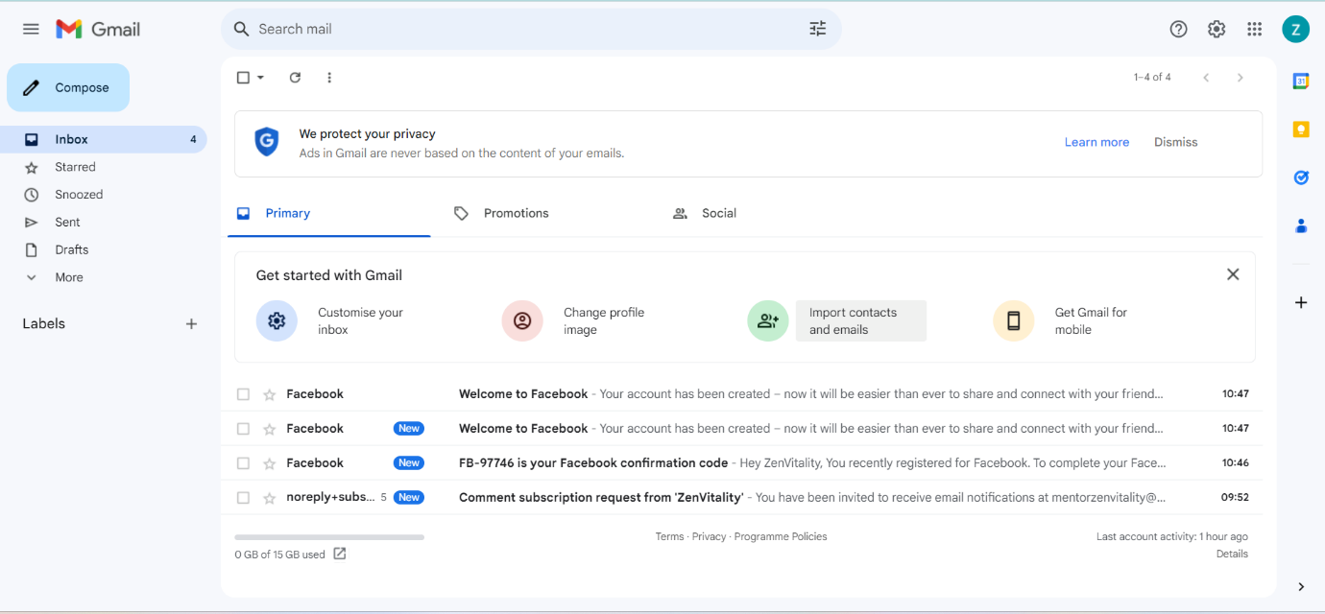

Facebook page:

**Facebook:** [www.facebook.com/ZenVitalityMentor](http://www.facebook.com/ZenVitalityMentor)

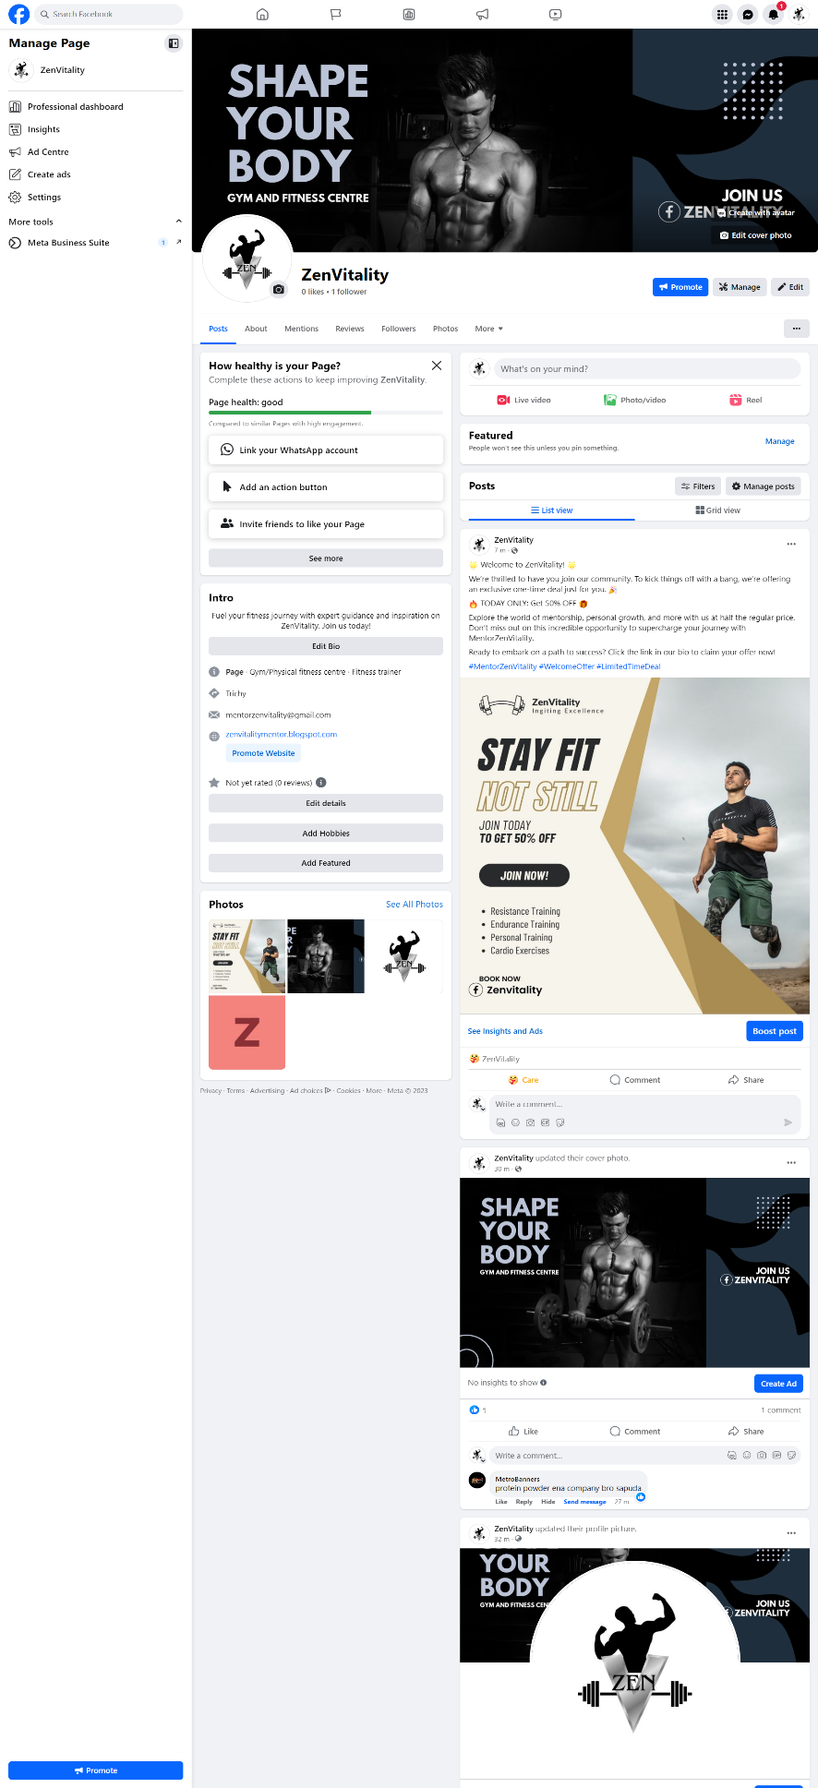

Blog:

**Blog:** [www.zenvitalitymentor.blogspot.com](http://www.zenvitalitymentor.blogspot.com)

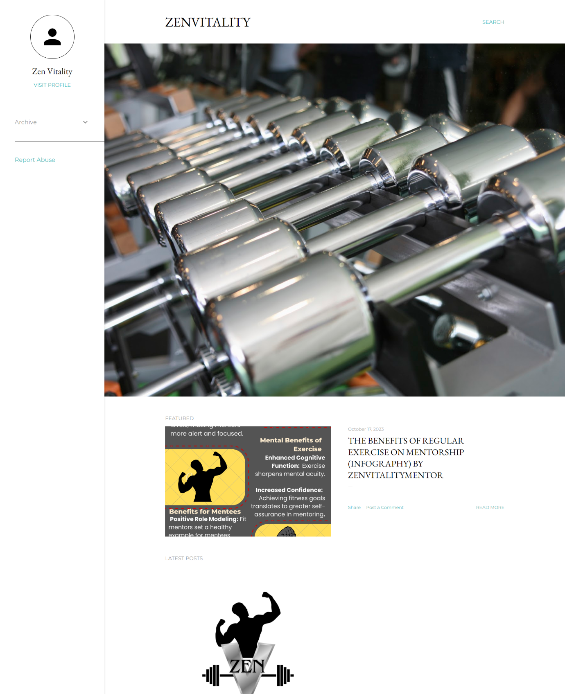

Google Analytic:

**Analytics:** G-LCVR7X01B0

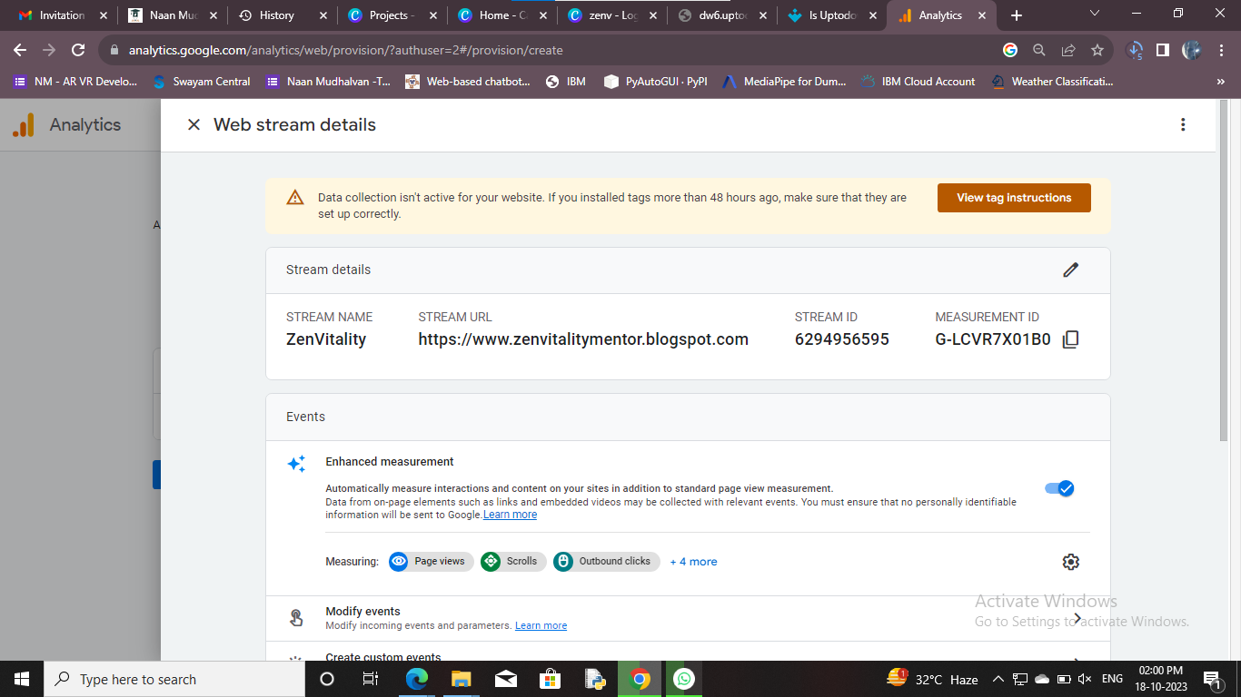

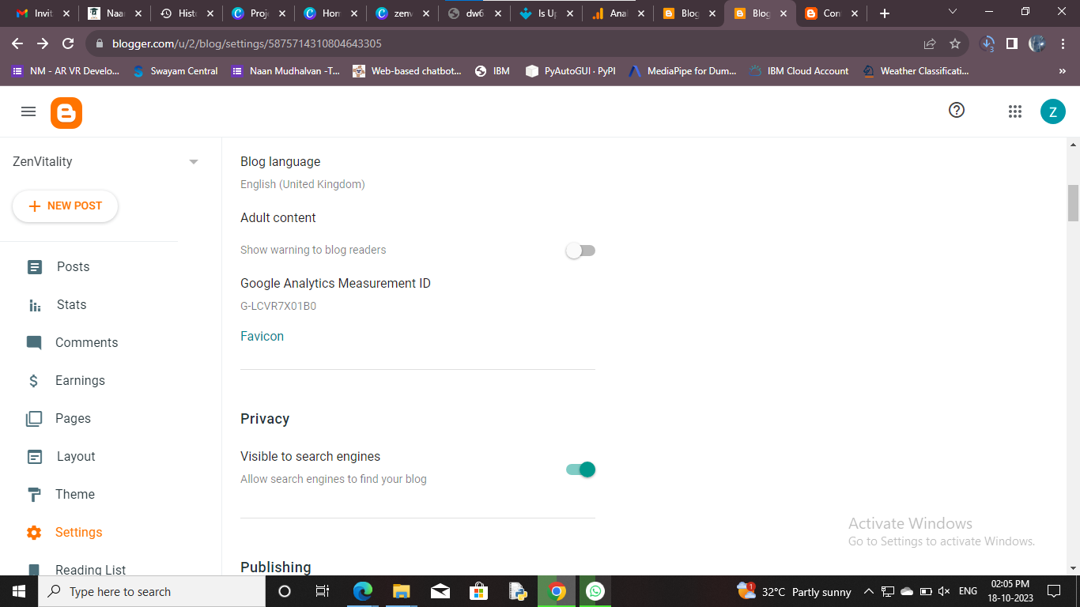

**Google Ads Campaign :**

**Demo link:**

<https://youtu.be/eKjSmUQ2AiU?si=zMA073VorjyhiapJ>

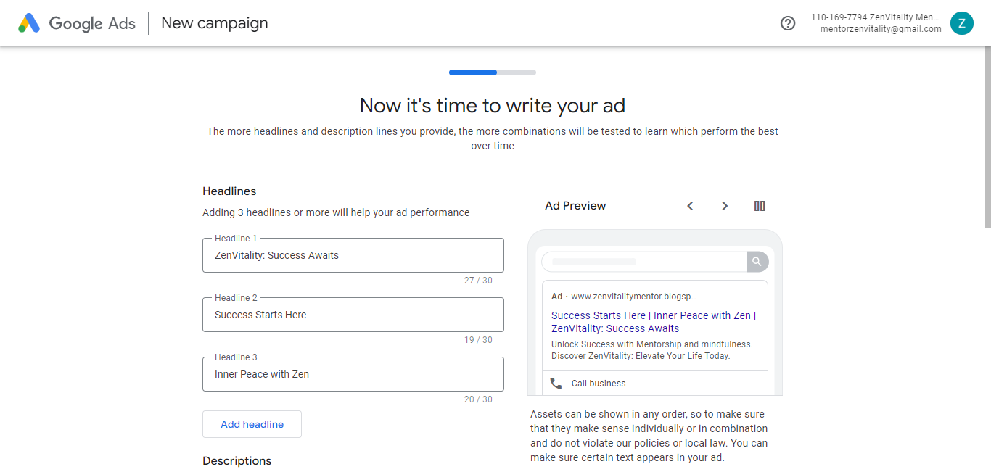

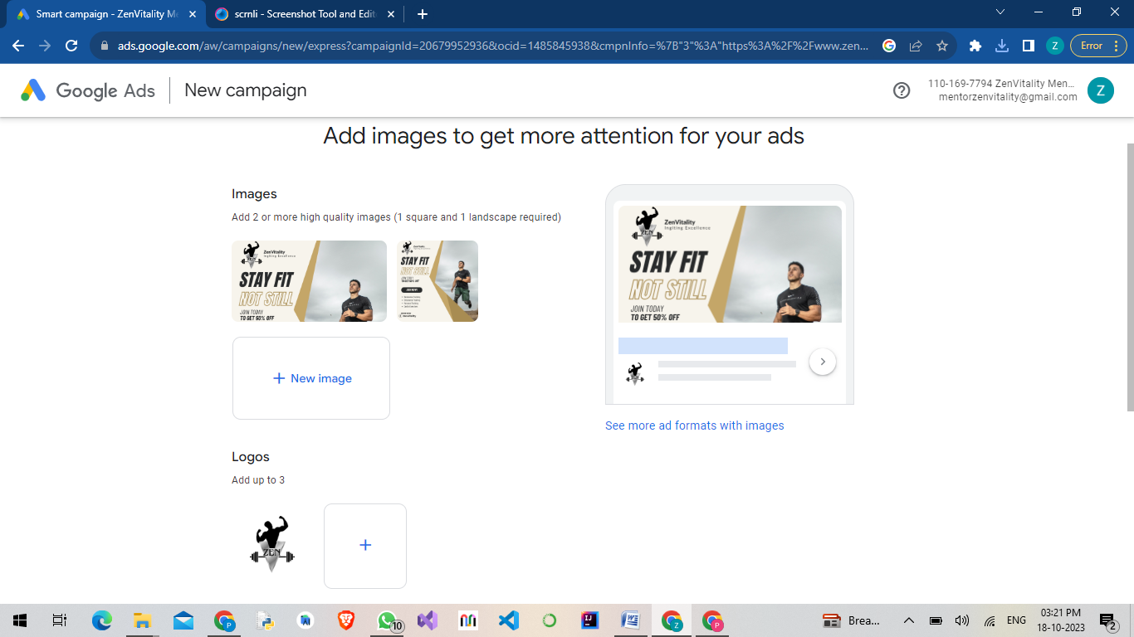

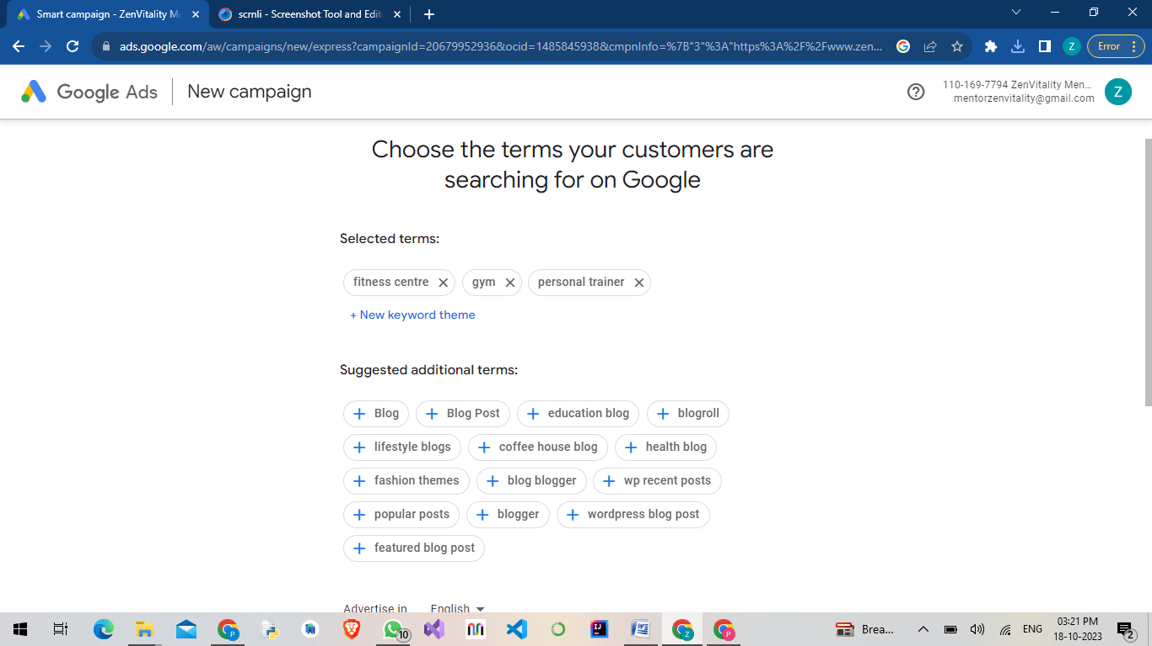

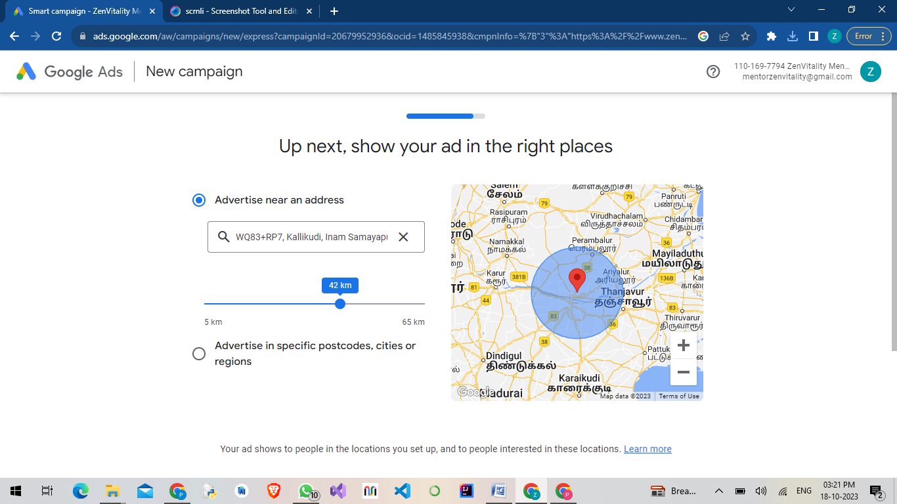

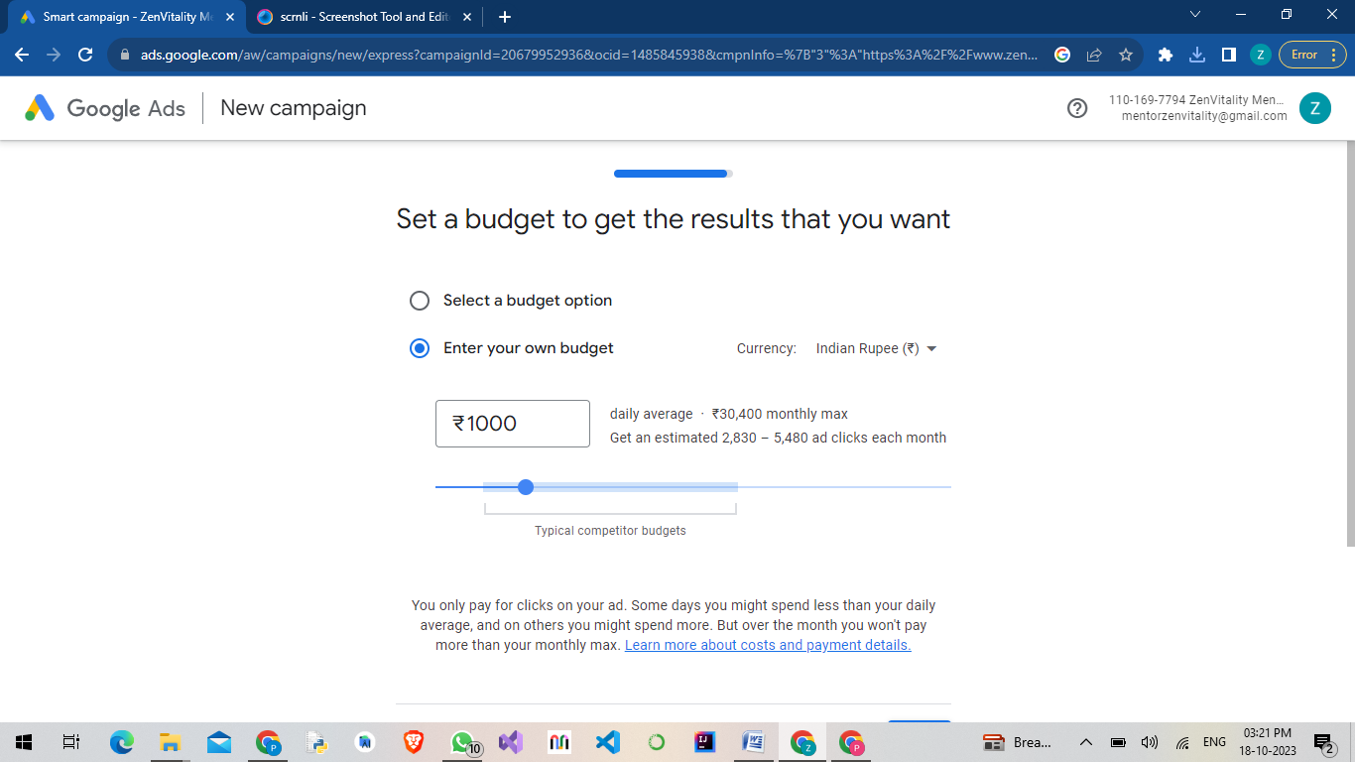

**A**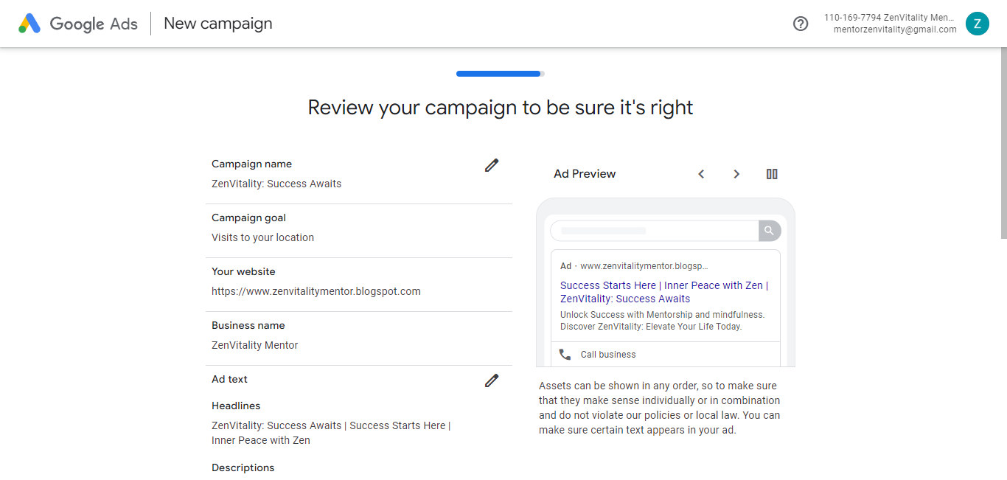

**Personal Assignment**

**Brand Name:**  Find Your Future

**Tag Line:** Live Your Best Life.

**Category:** Real Estate.

**Linked In:**  [www.linkedin.com/in/prasannart](http://www.linkedin.com/in/prasannart)

**Facebook:** [www.facebook.com/findurfuture143](http://www.facebook.com/findurfuture143)

**Blog:**  [www.fyf143.blogspot.com](http://www.fyf143.blogspot.com)

**Brand Intro:** [www.fyf143.blogspot.com/2023/08/finding-your-future-home-are-you-ready.html](http://www.fyf143.blogspot.com/2023/08/finding-your-future-home-are-you-ready.html)

**Email Newsletter:** [www.fyf143.blogspot.com/2023/08/email-news-letter-for-find-your-future.html](http://www.fyf143.blogspot.com/2023/08/email-news-letter-for-find-your-future.html)

**Infography:** [www.fyf143.blogspot.com/2023/08/5-key-points-to-success-in-property.html](http://www.fyf143.blogspot.com/2023/08/5-key-points-to-success-in-property.html)

**Google Analytics Measurement Id:** G-805E1BGG87